Memo

To: Daniel Ek, CEO of Spotify

From: Priscilla Clark, Head of Strategy

Subject: Strategic Direction for Spotify in AI Integration

Hi Daniel,

As requested, I’m writing to provide an assessment of our current AI positioning and recommend a vital opportunity that will cement Spotify’s position as a leader in leveraging AI within the streaming industry.

Our current AI strategy spans multiple streaming value chain segments, focusing on personalized recommendations, user engagement, and catalog management. Core components include:

1. **Personalization and Recommendations:** AI-powered features like “Discover Weekly” and “Spotify Wrapped” utilize advanced machine learning to enhance user experience. Recommendation systems influence nearly 50% of user-added playlist content[1].
2. **Catalog Management and Content Understanding:** As highlighted on our blog, tools like LLark and PODTILE exemplify Spotify's investment in content segmentation and metadata enrichment to streamline user access and improve discoverability[2] [3].
3. **User Behavior Insights:** Spotify uses AI to analyze user behavior, enabling precise targeting in advertising and playlist customization[4].

As I’m sure you know, Spotify has 640 million monthly active users (MAUs) and 252 million premium subscribers as of Q3 2024, achieving a 19% YoY revenue growth to approximately $4.5 billion USD[5]. The global music streaming market is projected to reach $103 billion by 2030[6], with AI-driven personalization being a key differentiator.

Despite these substantial growth numbers and large potential market size, Spotify faces significant competition in the streaming market, particularly from tech giants leveraging their broader ecosystems to enhance user experiences. Our key competitors include[7]:

1. **Apple Music** offers seamless transitions within the iOS ecosystem. While its AI-powered recommendation engine is robust, it lacks Spotify's level of playlist personalization and user engagement campaigns like Spotify Wrapped.
2. **Amazon Music** benefits from its inclusion in Amazon Prime subscriptions, and with voice integration via Alexa, Amazon Music offers a distinct advantage in smart speaker usage. However, its music recommendation algorithms are considered less sophisticated than ours.
3. **YouTube Music** leverages YouTube's vast data on video and audio consumption to offer personalized recommendations. YouTube's dominance in music video streaming gives it a broader reach than Spotify's audio-only model, though Spotify remains the leader in paid subscriptions[8].
4. **Tidal and Niche Players:** Tidal focuses on high-fidelity audio and artist-first strategies, catering to audiophiles and fans of exclusive content. However, its market share is small.

**Strategic Recommendation: Provide Generative AI Services to Artists**

I recommend developing a generative AI platform tailored for artists to strengthen Spotify's market position. This platform would empower creators with AI-driven tools for music composition, lyric generation, and production assistance. Expanding the AI services to artists will allow us to potentially yield approximately $500–$700 million USD annually in additional revenue. The service would enable us to provide value to artists in the following areas:

1. **Democratization of Music Production:** Independent and emerging artists often lack the resources for high-quality production. AI tools can bridge this gap by providing affordable, high-quality composition, mixing, and mastering tools. Empowering artists with professional-grade tools enhances our relationship with the creative community while increasing the volume and diversity of content on our platform.
2. **Customization and Personalization:** Offer AI-powered features that allow artists to tailor music to specific audience segments or moods. For example, artists could use AI to create alternate versions of their songs for workout playlists, romantic playlists, or live-streaming events.
3. **Streamline Collaborative Projects:** Artists could quickly match styles with potential collaborators worldwide through an AI matchmaking system.
4. **Enhancing Promotion and Monetization:** AI tools could assist artists in crafting personalized marketing campaigns by analyzing listener data and recommending optimal strategies, such as targeting audiences likely to share their music or attend concerts. Artists could also use AI to create visualizations or promotional videos that dynamically respond to their music's mood or tempo, providing fans unique experiences.
5. **Enable Real-Time Fan Engagement:** Introduce AI-driven lyric or beat generators that fans can interact with during live streams or releases, creating customized versions of songs with the artist’s oversight. AI could power fan polls or feedback loops for work-in-progress music, allowing artists to involve their audience in the creative process in unprecedented ways.

Developing and deploying generative AI services for artists will require a multi-year investment plan. Still, it will provide a brand-new revenue stream to the organization and add positive value to the music industry. Total estimated costs include $115–$165 million USD over three years[9].

1. **Research and Development:** $50–$70 million USD over three years to build AI models for music composition, lyrics, and production assistance.
2. **Infrastructure Costs:** $40–$60 million USD for training and hosting generative AI models on cloud platforms, ensuring seamless scalability.
3. **Talent and Partnerships:** $15–$20 million USD annually to recruit machine learning engineers, music producers, and data scientists and establish partnerships with artist communities. This number may be artificially high, given we already have good talent in-house.
4. **Integration and Deployment:** $10–$15 million USD for integrating the generative AI platform into Spotify’s existing artist tools, such as Spotify for Artists.

By 2028, these new artist-focused generative AI services could yield approximately $500–$700 million USD annually through:

* Subscription-based access to AI tools for independent and established artists
* Monetization of exclusive, AI-enhanced content on Spotify
* Revenue-sharing agreements with artists for AI-driven compositions licensed externally

Spotify’s pivot to providing generative AI services for artists aligns perfectly with our mission to empower creators and deliver transformative music experiences. By equipping artists with cutting-edge creation, collaboration, and fan engagement tools, Spotify can solidify its role as an indispensable partner in the music industry while driving new revenue streams.

This strategy ensures leadership in AI-driven music innovation and deepens Spotify’s connection to the artistic community, reinforcing our position as the most artist-friendly streaming platform. I look forward to discussing this opportunity further in our next 1:1.

Best regards,

Priscilla Clark

**Appendix**

**Link to Sources Folder**

<https://drive.google.com/drive/folders/1XODIellF0e_Z7A16KMmOMBdWLOncXzek?usp=drive_link>

**Custom GPT for Research and Ideation**

Uploaded sources

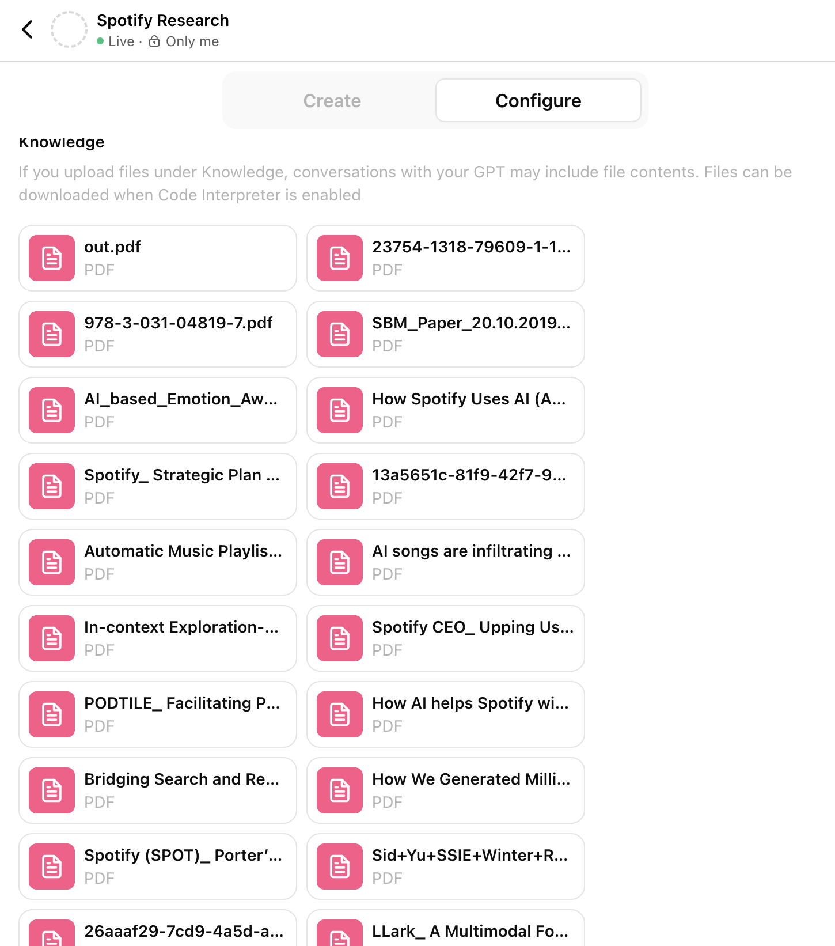

1. Björklund, G., Bohlin, M., Olander, E., Jansson, J., Walter, C. E., & Au-Yong-Oliveira, M. (2022). An exploratory study on the Spotify Recommender system. In *Lecture notes in networks and systems* (pp. 366–378). https://doi.org/10.1007/978-3-031-04819-7_36
2. Engineering, S. (2023, October 25). *LLARK: A multimodal foundation model for music - Spotify Research*. Spotify Research. https://research.atspotify.com/2023/10/llark-a-multimodal-foundation-model-for-music/
3. Jenny. (2024, October 24). *PODTILE: Facilitating Podcast Episode Browsing with Auto-generated Chapters - Spotify Research*. Spotify Research. https://research.atspotify.com/2024/10/podtile-facilitating-podcast-episode-browsing-with-auto-generated-chapters/
4. Alexandrawei. (2024, October 22). *How we generated millions of content annotations - Spotify Engineering*. Spotify Engineering. https://engineering.atspotify.com/2024/10/how-we-generated-millions-of-content-annotations/#:~:text=We%20took%20a%20straightforward%20ML,model%20training%20and%20evaluation%20workflows.
5. Pymnts. (2024, November 13). *Spotify CEO: Upping user engagement and Expanding AI use paid off*. PYMNTS.com. https://www.pymnts.com/earnings/2024/spotify-ceo-upping-user-engagement-and-expanding-ai-use-paid-off/
6. T, I. (2024, February 10). Music streaming subscription service market size to worth USD 103.07 billion by 2030 | with a 15% CAGR. *EIN Presswire*. https://www.einpresswire.com/article/687647506/music-streaming-subscription-service-market-size-to-worth-usd-103-07-billion-by-2030-with-a-15-cagr
7. *The value Engineers.nl*. (n.d.). https://www.thevalueengineers.nl/insights/strategic-analysis-of-the-music-streaming-ecosystem
8. Sletten, R. T. (2021). Spotify: Strategic plan and analysis. In *Undergraduate Theses, Professional Papers, and Capstone Artifacts* [Thesis]. https://scholarworks.umt.edu/cgi/viewcontent.cgi?article=1346&context=utpp
9. Jackson, F. (2024, September 6). Generative AI projects fail amid high costs and risks. *TechRepublic*. https://www.techrepublic.com/article/30-generative-ai-projects-fail-amid-high-costs-and-risks/